HULAAN SA BAYAN
SET UP GUIDE
1. Install Required Tools on Your Server VM

su
password: [Enter your password]
apt update
apt install g++
exit

2. Configure VirtualBox Network Settings
1. In Oracle VirtualBox, select your Ubuntu VM (the server).
2. Click Settings -> Network, then configure it the same as in the photo.
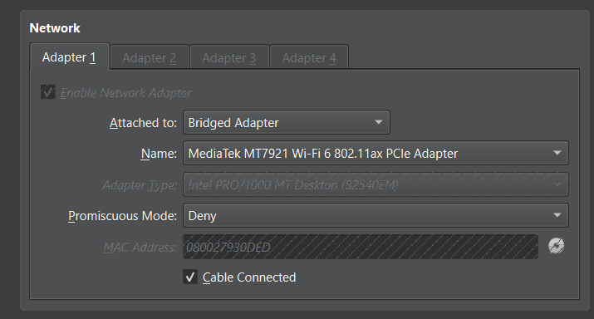

3. Find Your Server VM's IP Address
1. Inside your Ubuntu VM terminal, type:
hostname -I
2. Note the IP address shown. Example output:

192.168.1.43

4. Update Client Code
In your client-side code, change the server IP line to:
#define SERVER_IP "192.168.1.43"
(Replace 192.168.1.43 with your actual server VM's IP address.)

5. Compile and Run Your Server/Client Program
1. Navigate to the directory where your C++ file is located.
2. Compile your server code using:
g++ -std=c++23 yourfile.cpp -o yourprogram

3. Run your compiled server program:
./yourprogram

Quiz Game Client-Server Application Documentation
Overview
This is a real-time multiplayer quiz game built using C++ socket programming. The application consists of a server that hosts quiz sessions and multiple clients that can connect to participate in the quiz. The program was developed and deployed using a Cloud Virtual Private Server (Cloud Windows Server) for reliable hosting and accessibility.
System Architecture
Components
- Server Application (server.cpp) - Manages quiz sessions, handles multiple clients, and controls game flow
  - SOURCE CODE (AT THE BOTTOM)

- Client Application (client.cpp) - Connects players to the server and handles user interaction
  - SOURCE CODE (AT THE BOTTOM)

- CMake Build System (CMakeLists.txt) - Cross-platform build configuration
  - SOURCE CODE (AT THE BOTTOM)

Technology Stack
- Programming Language: C++20
- Networking: TCP/IP Socket Programming
- Platform Support: Windows (Winsock2) and Linux/Unix
- Build System: CMake 3.31+
- Deployment: Cloud Windows Server (Virtual Private Server)

Features
Server Features
The server application provides robust multi-client support, capable of handling up to 50 simultaneous connections through efficient thread management. It features an intelligent auto-start mechanism that automatically begins the game when a minimum of 2 players join, followed by a 30-second countdown period that allows additional players to connect before the quiz begins. The server maintains real-time scoring capabilities, continuously tracking and displaying player scores throughout the entire game session. It draws from an extensive question pool containing over 50 carefully curated questions about Philippine history, culture, and geography, ensuring diverse and engaging gameplay. After each game session concludes, the server automatically resets itself to prepare for the next round of players, providing continuous operation without manual intervention. The application is designed with cross-platform compatibility in mind, functioning seamlessly on both Windows and Linux systems.

Client Features
The client application offers a streamlined, command-line based interface that prioritizes simplicity and ease of use for players of all technical backgrounds. It maintains real-time communication with the server, ensuring instant message delivery and responsive gameplay experience. The client handles automatic disconnection procedures gracefully when the game ends, properly closing socket connections and freeing system resources. Like the server, the client application is built with cross-platform support, making it compatible with both Windows and Linux operating systems, allowing players from different platforms to participate in the same game session.
Game Mechanics
- Question Format: Multiple choice and short answer questions
- Scoring System: +10 points for correct answers
- Answer Matching: Case-insensitive answer checking with partial matching
- Game Duration: 5 random questions per session
- Leaderboard: Real-time score display and final rankings
- Winner Determination: Handles both single winners and tie scenarios

Network Configuration
Server Settings
- Port: 8080
- IP Address: 192.168.254.104 (configured for local network)
- Protocol: TCP/IP
- Buffer Size: 2048 bytes
- Connection Limit: 50 clients maximum

Minimum Requirements
- Players: 2 minimum to start a game
- Wait Time: 30 seconds countdown before game begins
- Network: Local area network or internet connection

Development Environment
IDE Configuration
The project uses a modern C++ IDE (CLion/Visual Studio/VS Code) with the following run configurations:
- NewParallelClient - Run configuration for the client application
- NewParallelServer - Run configuration for the server application

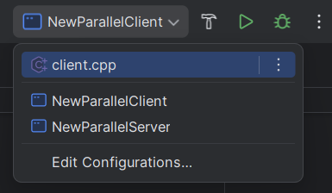

Build System Integration
The CMakeLists.txt file automatically creates these executable targets:
- NewParallelClient - Builds from client.cpp
- NewParallelServer - Builds from server.cpp

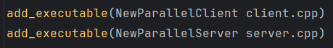

Both targets are configured with:
- C++20 standard
- Windows Winsock2 library linking (when on Windows)
- Cross-platform compatibility

Installation and Setup
Prerequisites
- C++ compiler with C++20 support
- CMake 3.31 or higher
- Windows: Visual Studio Build Tools or MinGW
- Linux: GCC or Clang compiler
- IDE: CLion, Visual Studio, or VS Code (recommended)

TEST CASES
Server Side
Test Case 1: Server Initialization
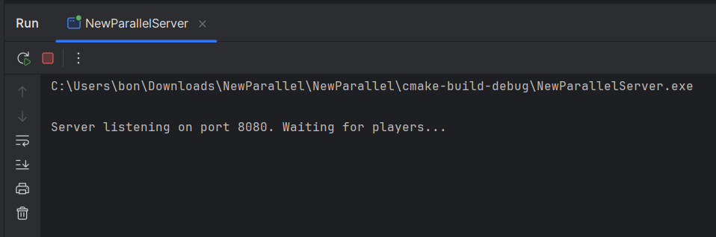

Test Case 2: First Player Connection (Player name 1 [Vhon] )
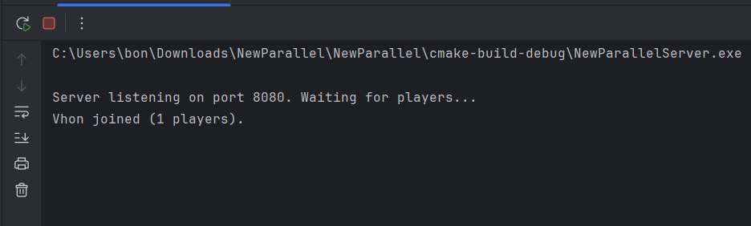

Test Case 3: Second Player Connection (Player name 2 [Eric] ) - Auto-start Triggered (after 30 seconds)
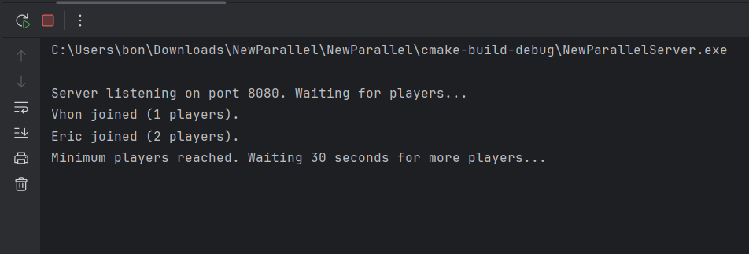
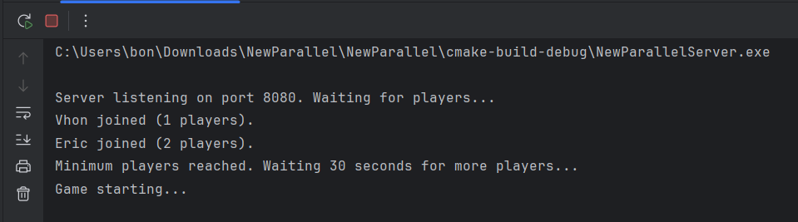

Client Side
Test Case 1: Vhon's Client Connection (First Player)
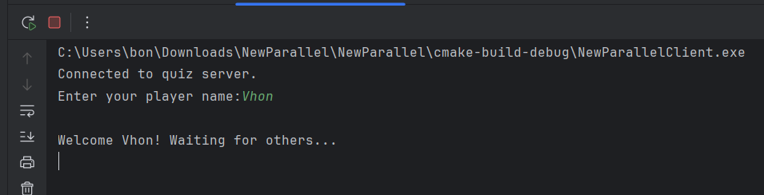

Test Case 2: Eric's Client Connection (Second Player)
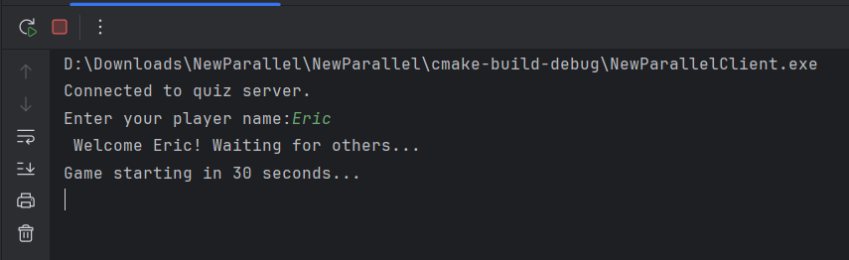

Test Case 3: Vhon's Client During Countdown
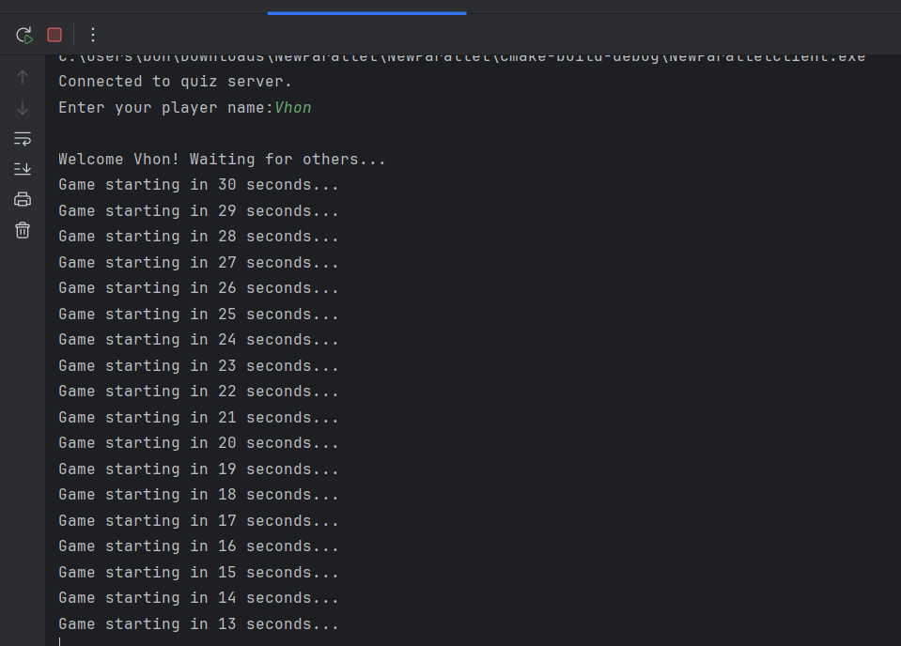

Test Case 4: Quiz Session - Sample Question for Both Players
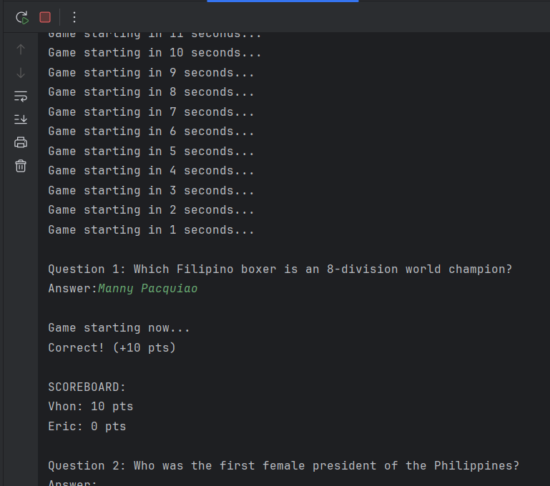
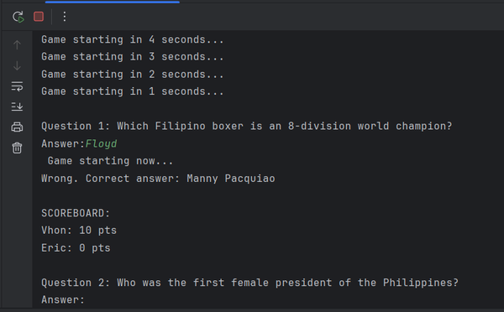

Test Case 4A: Quiz Session - Correct and Incorrect Answers
Expected Client Output (Vhon - Correct Answer):
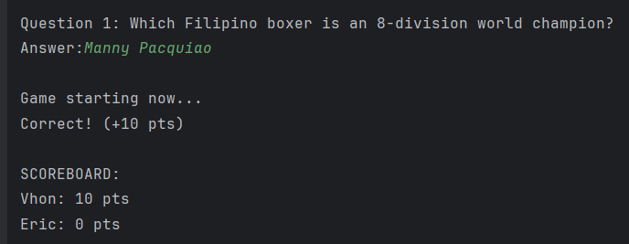

Expected Client Output (Eric - Incorrect Answer):

Test Case 5: Game Completion - Final Results
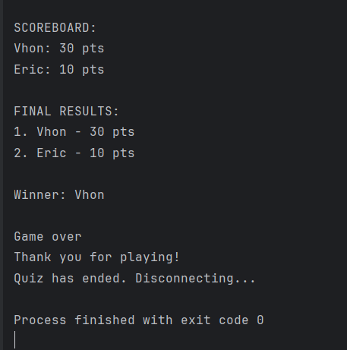

Test Case 6: Alternative Final Results (Tie Scenario)
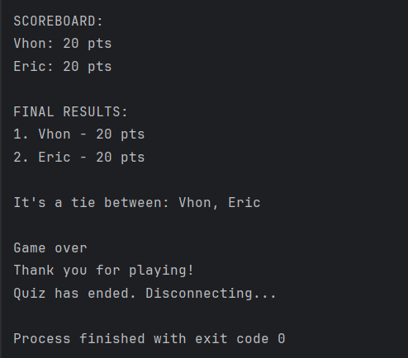

MEMBERS’ CONTRIBUTION:
CODE / PROGRAMMING: Jhevan Baque and Mikhael Gomez
DOCUMENTATION: Vhon Mercado
VIDEO PRESENTATION: Franc Hermogenes

SOURCE CODE:
client.cpp
// client.cpp - Quiz Game Client (Windows Compatible)
#include <iostream>
#include <string>
#include <cstring>
#ifdef _WIN32
#include <winsock2.h>
#include <ws2tcpip.h>
#pragma comment(lib, "ws2_32.lib")
#else
#include <unistd.h>
#include <arpa/inet.h>
#include <sys/socket.h>
#endif
using namespace std;
#define SERVER_IP "192.168.254.104" // Changed to localhost
#define PORT 8080
#define BUFFER_SIZE 2048
int main() {
#ifdef _WIN32
// Initialize Winsock
WSADATA wsaData;
int wsInit = WSAStartup(MAKEWORD(2, 2), &wsaData);
if (wsInit != 0) {
cerr << "WSAStartup failed with error: " << wsInit << endl;
return 1;
}
#endif
int client_socket = socket(AF_INET, SOCK_STREAM, 0);
#ifdef _WIN32
if (client_socket == INVALID_SOCKET) {
cerr << "Socket creation failed. Error: " << WSAGetLastError() << endl;
WSACleanup();
return 1;
}
#else
if (client_socket < 0) {
perror("socket");
return 1;
}
#endif
sockaddr_in server_addr{};
server_addr.sin_family = AF_INET;
server_addr.sin_port = htons(PORT);
if (inet_pton(AF_INET, SERVER_IP, &server_addr.sin_addr) <= 0) {
cerr << "Invalid address/ Address not supported.\n";
#ifdef _WIN32
closesocket(client_socket);
WSACleanup();
#else
close(client_socket);
#endif
return 1;
}
if (connect(client_socket, (sockaddr*)&server_addr, sizeof(server_addr)) < 0) {
cerr << "Connection failed.\n";
#ifdef _WIN32
closesocket(client_socket);
WSACleanup();
#else
close(client_socket);
#endif
return 1;
}
cout << "Connected to quiz server.\nEnter your player name: ";
string name;
getline(cin, name);
send(client_socket, name.c_str(), static_cast<int>(name.size()), 0);
char buffer[BUFFER_SIZE]{};
while (true) {
memset(buffer, 0, BUFFER_SIZE);
int bytes_received = recv(client_socket, buffer, BUFFER_SIZE - 1, 0);
if (bytes_received <= 0) {
cout << "Disconnected from server.\n";
break;
}
buffer[bytes_received] = '\0';
string received_msg(buffer);
cout << received_msg;
// Detect game over and exit
if (received_msg.find("Game over") != string::npos) {
cout << "Quiz has ended. Disconnecting...\n";
break;
}
// Prompt for answer if expected
if (received_msg.length() >= 8 &&
received_msg.substr(received_msg.length() - 8) == "Answer: ") {
string answer;
getline(cin, answer);
send(client_socket, answer.c_str(), static_cast<int>(answer.size()), 0);
}
}
#ifdef _WIN32
closesocket(client_socket);
WSACleanup();
#else
close(client_socket);
#endif
return 0;
}

server.cpp
// server.cpp - Quiz Game Server (Auto-Start After 2 Players + Reset Loop)
#include <iostream>
#include <string>
#include <vector>
#include <algorithm>
#include <random>
#include <thread>
#include <mutex>
#include <atomic>
#include <chrono>
#include <cstring>
#ifdef _WIN32
#include <winsock2.h>
#include <ws2tcpip.h>
#pragma comment(lib, "ws2_32.lib")
#else
#include <unistd.h>
#include <arpa/inet.h>
#include <sys/socket.h>
#endif
using namespace std;
#define PORT 8080
#define BUFFER_SIZE 2048
#define MAX_CLIENTS 50
#define START_AFTER_SECONDS 30
#define MIN_PLAYERS 2
struct ClientInfo {
SOCKET socket;
string name;
int score = 0;
bool disconnected = false;
};
struct Question {
string question;
string correct;
};
mutex clients_mutex;
vector<Question> questions_pool = {
{"What is the capital of the Philippines?", "Manila"},
{"Who was the first president of the Philippines?", "Emilio Aguinaldo"},
{"What is the national language of the Philippines?", "Filipino"},
{"What is the largest island in the Philippines?", "Luzon"},
{"Who is known as the Hero of Tirad Pass?", "Gregorio del Pilar"},
{"Which Filipino boxer is an 8-division world champion?", "Manny Pacquiao"},
{"What is the longest river in the Philippines?", "Cagayan River"},
{"What is the Philippine national fruit?", "Mango"},
{"Which volcano had a major eruption in 1991?", "Mount Pinatubo"},
{"What is the name of the Philippine national anthem?", "Lupang Hinirang"},
{"Who wrote Noli Me Tangere?", "Jose Rizal"},
{"Which city is known as the Summer Capital of the Philippines?", "Baguio"},
{"What Filipino festival is held in Cebu every January?", "Sinulog"},
{"Which island is famous for its white sand beach?", "Boracay"},
{"Who was the first Filipina Miss Universe?", "Gloria Diaz"},
{"What is the national bird of the Philippines?", "Philippine Eagle"},
{"Which body of water lies to the west of the Philippines?", "South China Sea"},
{"Who is considered the Father of the Philippine Revolution?", "Andres Bonifacio"},
{"What is the traditional Filipino house called?", "Bahay Kubo"},
{"Which city is known as the Queen City of the South?", "Cebu City"},
{"What is the currency of the Philippines?", "Peso"},
{"What is the Filipino martial art that uses sticks?", "Arnis"},
{"Which is the highest mountain in the Philippines?", "Mount Apo"},
{"Which Philippine hero was known as The Sublime Paralytic?", "Apolinario Mabini"},
{"Which Philippine festival celebrates the bountiful harvest in Lucban, Quezon?", "Pahiyas Festival"},
{"Which dish is made of pork or chicken stewed in soy sauce and vinegar?", "Adobo"},
{"Which Philippine island is known for the Chocolate Hills?", "Bohol"},
{"Who discovered the Philippines for Spain in 1521?", "Ferdinand Magellan"},
{"Which sea creature is featured on the old 1-centavo coin?", "Bangus"},
{"What is the Filipino term for traditional tattooing?", "Batok"},
{"What is the smallest province in the Philippines?", "Batanes"},
{"What city is known as the Walled City?", "Intramuros"},
{"Who is the national hero of the Philippines?", "Jose Rizal"},
{"Which mountain is the highest in the Philippines?", "Mount Apo"},
{"What is the currency of the Philippines?", "Peso"},
{"Which city is known as the City of Pines?", "Baguio"},
{"What Filipino dish is known for its sour broth?", "Sinigang"},
{"Which island is famous for the Chocolate Hills?", "Bohol"},
{"Who was the first female president of the Philippines?", "Corazon Aquino"},
{"What sea lies east of the Philippines?", "Philippine Sea"},
{"What is the most active volcano in the Philippines?", "Mayon Volcano"},
{"Which city is known as the Queen City of the South?", "Cebu"},
{"What is the national tree of the Philippines?", "Narra"},
{"Which hero is known as the Great Plebeian?", "Andres Bonifacio"},
{"What is the national flower of the Philippines?", "Sampaguita"},
{"Which island is known for its surfing waves?", "Siargao"},
{"What is the Philippine national dance?", "Tinikling"},
{"What is the main ingredient of Laing?", "Gabi Leaves"},
{"Which festival is celebrated in Iloilo?", "Dinagyang"},
{"Who is the Father of the Philippine Constitution?", "Felipe Calderon"},
{"Which province is known for the Moriones Festival?", "Marinduque"},
{"Who painted the Spoliarium?", "Juan Luna"},
{"Which body of water separates Luzon and Mindoro?", "Verde Island Passage"},
{"What is the name of the Filipino sun god?", "Apolaki"},
{"What instrument is used in traditional Filipino kulintang music?", "Gongs"},
{"What fruit is known as the King of Fruits in the Philippines?", "Durian"},
{"What is the meaning of the word Luzon?", "Big land"},
{"Which Filipino invented the Moon Buggy used on the moon?", "Eduardo San Juan"},
{"What is the main mode of transportation in the Philippines?", "Jeepney"}
};
void send_to_client(SOCKET sock, const string& msg) {
send(sock, msg.c_str(), static_cast<int>(msg.size()), 0);
}
void broadcast(const vector<ClientInfo>& clients, const string& message) {
for (const auto& client : clients) {
if (!client.disconnected) {
send_to_client(client.socket, message);
}
}
}
void close_socket(SOCKET sock) {
#ifdef _WIN32
closesocket(sock);
#else
close(sock);
#endif
}
vector<ClientInfo> clients;
atomic<bool> game_started{false};
void handle_client(SOCKET client_socket) {
char buffer[BUFFER_SIZE]{};
int bytes_received = recv(client_socket, buffer, BUFFER_SIZE - 1, 0);
if (bytes_received <= 0) {
close_socket(client_socket);
return;
}
buffer[bytes_received] = '\0';
string player_name(buffer);
{
lock_guard<mutex> lock(clients_mutex);
clients.push_back({client_socket, player_name});
cout << player_name << " joined (" << clients.size() << " players).\n";
send_to_client(client_socket, "Welcome " + player_name + "! Waiting for others...\n");
}
if (clients.size() == MIN_PLAYERS && !game_started.exchange(true)) {
thread([] {
cout << "Minimum players reached. Waiting 30 seconds for more players...\n";
for (int i = START_AFTER_SECONDS; i > 0; --i) {
string countdown_msg = "Game starting in " + to_string(i) + " seconds...\n";
broadcast(clients, countdown_msg);
this_thread::sleep_for(chrono::seconds(1));
}
broadcast(clients, "Game starting now...\n");
cout << "Game starting...\n";
}).detach();
}
}
void run_quiz_round() {
vector<Question> questions = questions_pool;
shuffle(questions.begin(), questions.end(), mt19937(random_device{}()));
int num_questions = min(5, (int)questions.size());
for (int i = 0; i < num_questions; ++i) {
string qtext = "\nQuestion " + to_string(i + 1) + ": " + questions[i].question + "\nAnswer: ";
broadcast(clients, qtext);
vector<thread> threads;
{
lock_guard<mutex> lock(clients_mutex);
for (auto& client : clients) {
threads.emplace_back([&client, &q = questions[i]]() {
char buffer[BUFFER_SIZE]{};
int len = recv(client.socket, buffer, BUFFER_SIZE - 1, 0);
if (len <= 0) {
client.disconnected = true;
close_socket(client.socket);
return;
}
buffer[len] = '\0';
string answer = buffer;
string correct = q.correct;
transform(answer.begin(), answer.end(), answer.begin(), ::tolower);
transform(correct.begin(), correct.end(), correct.begin(), ::tolower);
if (answer == correct || answer.find(correct) != string::npos) {
client.score += 10;
send_to_client(client.socket, "Correct! (+10 pts)\n");
} else {
send_to_client(client.socket, "Wrong. Correct answer: " + q.correct + "\n");
}
});
}
}
for (auto& t : threads) t.join();
string scoreboard = "\nSCOREBOARD:\n";
for (const auto& client : clients) {
if (!client.disconnected) {
scoreboard += client.name + ": " + to_string(client.score) + " pts\n";
}
}
broadcast(clients, scoreboard);
}
string result = "\nFINAL RESULTS:\n";
vector<ClientInfo> finalists;
for (auto& c : clients)
if (!c.disconnected) finalists.push_back(c);
sort(finalists.begin(), finalists.end(),
[](const ClientInfo& a, const ClientInfo& b) { return a.score > b.score; });
for (size_t i = 0; i < finalists.size(); i++) {
result += to_string(i + 1) + ". " + finalists[i].name + " - " + to_string(finalists[i].score) + " pts\n";
}
if (!finalists.empty()) {
int top = finalists[0].score;
vector<string> winners;
for (auto& c : finalists)
if (c.score == top) winners.push_back(c.name);
if (winners.size() == 1)
result += "\nWinner: " + winners[0] + "\n";
else {
result += "\nIt's a tie between: ";
for (size_t i = 0; i < winners.size(); ++i) {
result += winners[i];
if (i != winners.size() - 1) result += ", ";
}
result += "\n";
}
}
broadcast(clients, result + "\nGame over\nThank you for playing!\n");
for (auto& c : clients) {
if (!c.disconnected) {
close_socket(c.socket);
}
}
}
int main() {
#ifdef _WIN32
WSADATA wsa;
WSAStartup(MAKEWORD(2, 2), &wsa);
#endif
while (true) {
clients.clear();
game_started = false;
SOCKET server_socket = socket(AF_INET, SOCK_STREAM, 0);
sockaddr_in server_addr{};
server_addr.sin_family = AF_INET;
server_addr.sin_addr.s_addr = INADDR_ANY;
server_addr.sin_port = htons(PORT);
if (bind(server_socket, (sockaddr*)&server_addr, sizeof(server_addr)) < 0) {
cerr << "Bind failed.\n";
close_socket(server_socket);
continue;
}
listen(server_socket, MAX_CLIENTS);
cout << "\nServer listening on port " << PORT << ". Waiting for players...\n";
thread([server_socket]() {
while (!game_started) {
sockaddr_in client_addr{};
socklen_t len = sizeof(client_addr);
SOCKET client_socket = accept(server_socket, (sockaddr*)&client_addr, &len);
if (client_socket >= 0) {
thread(handle_client, client_socket).detach();
}
this_thread::sleep_for(chrono::milliseconds(100));
}
}).detach();
while (!game_started) this_thread::sleep_for(chrono::milliseconds(100));
this_thread::sleep_for(chrono::seconds(START_AFTER_SECONDS));
run_quiz_round();
close_socket(server_socket);
cout << "\nRestarting server...\n";
this_thread::sleep_for(chrono::seconds(3));
}
#ifdef _WIN32
WSACleanup();
#endif
return 0;
}

CMakeLists.txt
cmake_minimum_required(VERSION 3.31)
project(NewParallel)
set(CMAKE_CXX_STANDARD 20)
add_executable(NewParallelClient client.cpp)
add_executable(NewParallelServer server.cpp)
# Link Winsock on Windows for both targets
if(WIN32)
target_link_libraries(NewParallelClient ws2_32)
target_link_libraries(NewParallelServer ws2_32)
endif()

